# Media Analysis - Is the Arab world ready for the uncertain age of AI-powered web tools_Updated 09 March 2023

## Short Summary

The summary of the article discusses the impact and potential of Artificial Intelligence AI in various sectors, including education, business, and media.

## Summary

1. The global market value of AI in 2022 was estimated to be $119.78 billion.  
2. AI is expected to contribute $15.7 trillion to the global economy by 2030, representing a growth of 13x over the next 8 years.  
3. There are currently around 97 million people working in the AI industry globally and this number is projected to grow significantly.  
4. ChatGPT, a large-language model, is trained on billions of words of text data from various sources, enabling it to predict words and sentences in certain sequences based on patterns it has learned. However, it does not understand things in the conventional sense and its output should be taken with a pinch of salt.  
5. AI has the potential to revolutionize many industries, including entertainment, medical diagnosis, and legal services, but it also raises concerns about job displacement and ethical issues such as bias and privacy.  
6. Trust is key to the safe expansion of the use of AI solutions around the world. While there are tasks that can be better suited to automation with technology, the use of AI is still contingent upon human intelligence and awareness.  
7. The age of AI remains fraught with anxiety, with some people believing it will completely replace humans while others believe we are many generations away from this happening.  
8. In the UAE, Minister of Education Ahmed Belhoul Al-Falasi has emphasized the importance of using AI as a tool to assist in content creation and improve efficiency, rather than demonizing it as a threat to human creativity and employment.  
9. Jenna Burrell, director of research at Data Society, an independent non-profit research organization based in California, cautions that while AI can be useful for journalists, its information should be fact-checked as it is not up-to-date.  
10. Large-language models such as ChatGPT are limited to generating text based on patterns and do not understand things in the same way humans do. They are also not necessarily the most sophisticated form of AI, with other models such as reinforcement learning, generative adversarial networks, and symbolic AI emerging as alternatives.

## Question 1

In the analyzed text, the media framing of the public discussion about ChatGPT can be observed through the use of several metaphors and recurring themes. 1. **Tool metaphor** ChatGPT is often described as a tool or instrument, such as I even passed exams at Minnesota University Law School and assist in content creation on social media, blogs, and websites. This framing emphasizes that ChatGPT is not an independent entity but rather a technology designed to perform specific tasks for human users. 2. **Pattern-matching metaphor** The text describes ChatGPT as a machine that matches patterns, which highlights its ability to generate text based on the data it was trained on without understanding in a conventional sense. This framing focuses on ChatGPT s limitations and helps set realistic expectations for users about its capabilities. 3. **Potential-threat metaphor** Although not overly prominent, there is an underlying suggestion that ChatGPT may pose a potential threat to certain professions, such as journalism, writing, or even higher education. This is evident in statements like There is a need for fact-checking and I am not able to replicate human innovation, creativity, skepticism, and reasoning. 4. **Caution metaphor** There are recurring cautions about the use of AI, with phrases such as need to take ChatGPT s answers with a pinch of salt or emphasizing the importance of fact-checking when using it for information gathering. This framing aims to educate users on the potential pitfalls and limitations of relying solely on AI. 5. **Promise metaphor** The text highlights the immense investment potential in AI, with forecasted values in the trillions of dollars, as well as its many possible applications across various industries like entertainment, medical diagnosis, etc. This framing focuses on the exciting possibilities that ChatGPT and other AI solutions could bring to society and the economy. Overall, these metaphors help shape public perception about ChatGPT by emphasizing its limitations, potential threats, and promises while encouraging caution when using it for various tasks.

## Question 2

The provided text mainly covers the following perspectives and aspects of Artificial Intelligence AI 1. Application and use cases of AI across various sectors such as education, media, law, and business. 2. Investment potential in the AI industry with forecasted valuations in trillions of dollars. 3. The limitations of AI, such as its inability to understand things in a conventional sense or replicate human creativity and emotion. 4. Concerns about trust, ethics, and the responsible use of AI in various aspects of society. 5. The potential impact of AI on employment, particularly in relation to the number of people projected to work in the industry by 2024 97 million . 6. Efforts to prevent cheating using AI, such as programs that claim to catch text written by AI. 7. Discussions around fact-checking and the need for human oversight when using AI for news coverage or other critical information dissemination. 8. The role of governments and educational institutions in regulating and promoting responsible AI adoption. Aspects that seem to be somewhat ignored in this text include 1. A comprehensive exploration of alternative models of AI e.g., reinforcement learning, generative adversarial networks, symbolic AI and their current status or potential impact on the landscape. 2. The social and cultural implications of widespread AI adoption beyond employment and education, such as privacy concerns, bias in AI systems, or the psychological effects of increased reliance on machines for everyday tasks. 3. Detailed discussion of the progress and challenges in developing advanced forms of AI, such as AGI artificial general intelligence or ASI artificial superintelligence . 4. Exploration of potential collaborations between humans and AI in various sectors to create a symbiotic relationship rather than a competitive one.

## Question 3

Not mentioned

## Question 4

The article highlights the growing influence and potential of AI, with investments in trillions and applications ranging from entertainment to medical diagnosis. However, concerns about its impact on employment, ethics, and trust remain. The final message emphasizes the importance of human intelligence and awareness in the safe expansion of AI use.

## Sentiment

The sentiment is 1.0

## Entities

AFP However, Generative Pre-Trained Transformer, Google, DeenSquare, LEAP, Elon Musk, YouTube, Bard, PwC Middle Easts, AI, Guardian, Sam Altman, Intelligence, Googles, Scott Nowson, UAE, Alex Hern, Reid Ho, Noaman Sayed, Nowson, Dubais Museum of the Future, Edge, Ahmed Belhoul Al-Falasi, OpenAI, Burrell, Arab News, the World Economic Forum, AFP Founded, Microsoft, Alexa, Omar Sultan Al-Olama, Bing, the Sciences Po school, Minnesota University Law School, Dan Milmo, ChatGPT, Peter Thiel, James Webb, New York Citys, GPT, National Strategy for Data, Jenna Burrell, LinkedIn, Data Society

## Highlights

#7cc867#fb5b89#c885da#f9cd59

## Wordcloud for #7cc867 Highlights

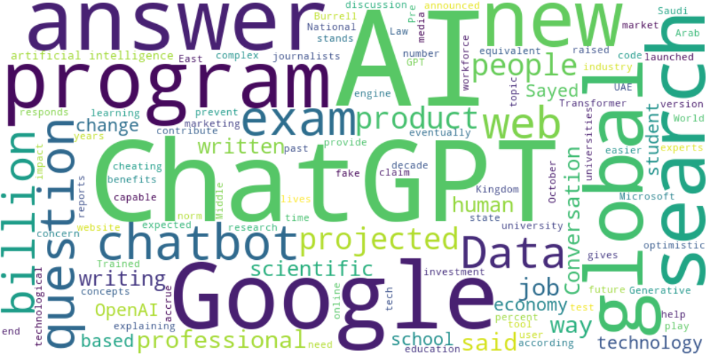

Top 10 words:

- AI: 16

- ChatGPT: 11

- Google: 7

- global: 5

- search: 5

- questions: 4

- web: 4

- billion: 4

- people: 4

- said: 4

## Wordcloud for #fb5b89 Highlights

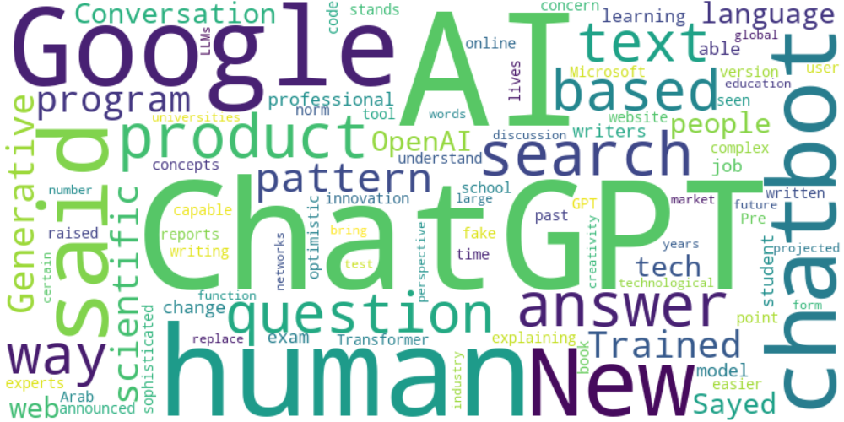

Top 10 words:

- AI: 12

- ChatGPT: 11

- Google: 7

- human: 5

- said: 5

- search: 4

- based: 4

- text: 4

- scientific: 3

- language: 3

## Wordcloud for #c885da Highlights

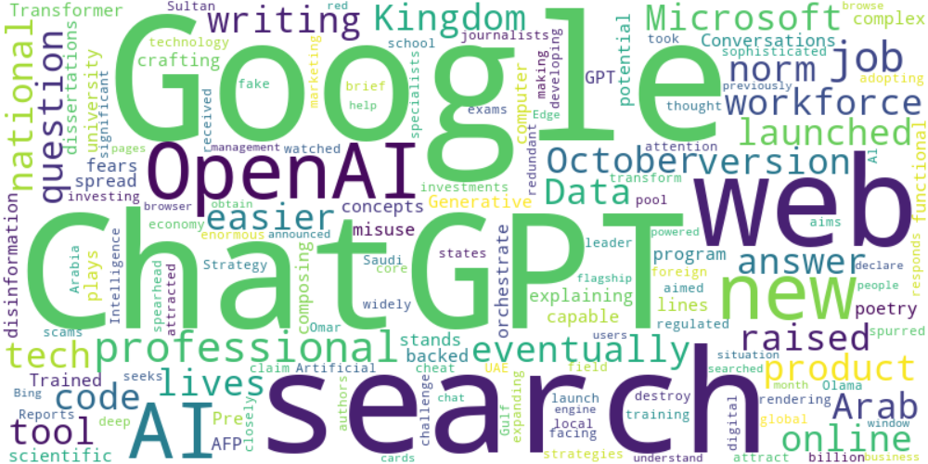

Top 10 words:

- Google: 6

- ChatGPT: 5

- search: 4

- web: 3

- OpenAI: 3

- AI: 3

- writing: 2

- code: 2

- Microsoft: 2

- raised: 2

## Wordcloud for #f9cd59 Highlights

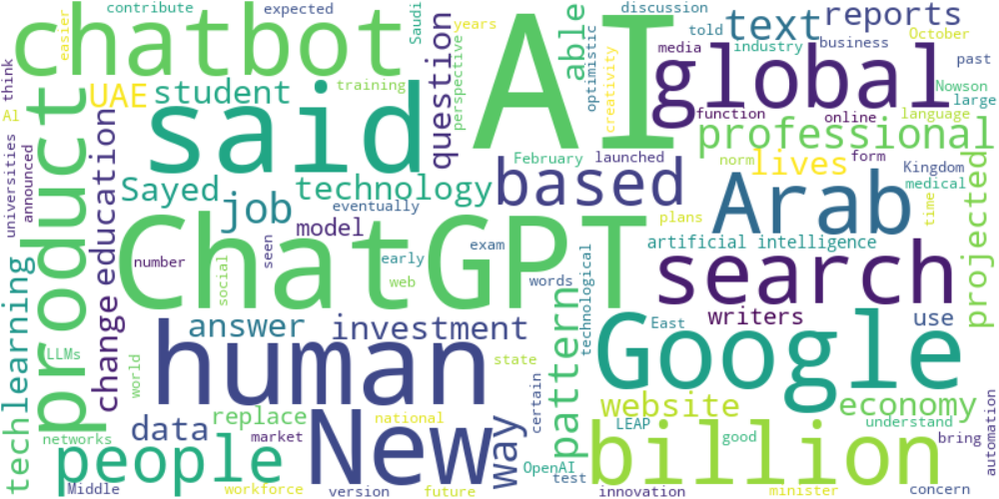

Top 10 words:

- AI: 24

- ChatGPT: 9

- said: 8

- Google: 6

- human: 5

- Arab: 4

- global: 4

- search: 4

- based: 4

- text: 4